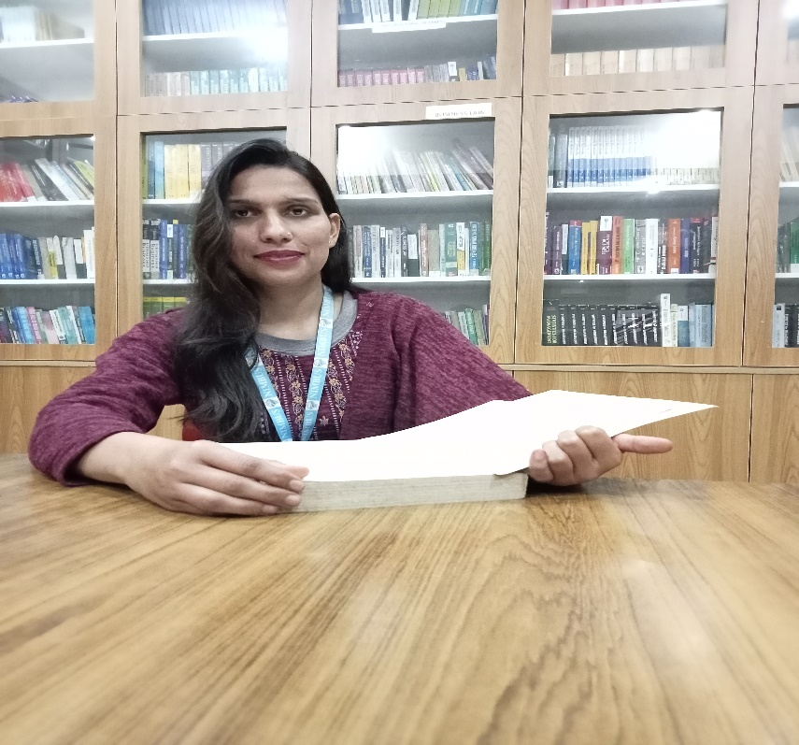

Vandana Bhandari

Assistant professor

Area
Primary Area : Human Resources Management
Secondary Area : Marketing Management

Contact
Email : Vandnab09@gmail.com
Phone : 7983014879

Education
B.Sc (Zoology, Botany , Chemistry) SRT CAMPUS
MBA (Human Resource Management) Sri Guru Ram Rai University Dehradun

Teaching

- Human Resource Management
- Organizational Behaviour
- Company Law
- Business Policy and Strategy

Research Area
- HRM Practices
- Labour and Social Welfare
- Organizational Behaviour

Academic Experience
Faculty Member, Minerva Group of Institutions, September 2022 onwards
Faculty Member , Nimbus Academy Management, October 2023 onwards

Professional Experience
Nimbus Academy of Management

